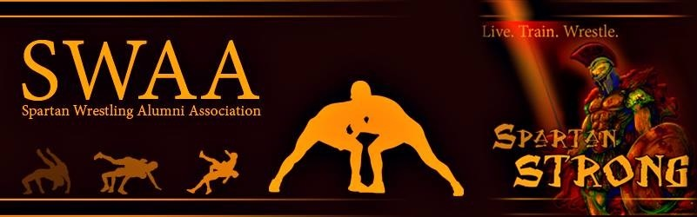

**Spartan Wrestling Alumni Association Hall of Fame**

The Spartan Wrestling Alumni Association Hall of Fame honors those who have achieved and served the Broad Run High School Spartan Wrestling Program with honor.

**Nomination Procedures**

* All former Spartan Wrestlers, Coaches, Parents, and Contributors/Sponsors can be nominated
* All Members of Hall of Fame become HOF Committee members
* Nomination form can be found online at [www.ashburnwrestlingclub.com/#!swaa/cspj](http://www.ashburnwrestlingclub.com/#!swaa/cspj)
* Nominations should be submitted electronically by October 1. Nomination should include brief resume of the individual’s qualifications.

**Who Can Nominate**

* Anyone can nominate a wrestler, coach, parent or contributor through the online process.

**Who is Eligible for the SWAA Hall of Fame?**

**Wrestlers:**

* Athlete in good standing with the program
* Must be with Varsity program no less than 2 years
* Must be Broad Run graduate
* Minimum of 5 years removed from program

**Coaches**

* Served in any coaching capacity minimum of 5 years
* Retired from program in good standing with school

**Parents/Contributors**

* Must have served/ volunteered with program for minimum five (5) years
* May be inducted posthumously

**Who serves on Selection Committee?**

* All Registered SWAA Members, HOF members, and current coaching staff may serve on Selection Committee
  + Registration subscription of $25 can be made at [www.ashburnwrestlingclub.com/#!swaa/cspj](http://www.ashburnwrestlingclub.com/#!swaa/cspj)
* Committee members should be able to commit to attend one meeting, either live or virtual, during the fall/winter selection process
* Any member of the committee who earns nomination, may not serve that year.

**The Selection Process**

* All nominees will be vetted by committee chair to ensure they meet the above criteria.
* All nominee forms and materials will be sent to committee members for review no later than Oct 15.
* Committee members generate a ranking of nominees, with explanations, by Nov. 1
* A meeting, live or virtual, will be held by November 15 to select the inductee. An order of Inductees will be generated. Inductee #1 will be notified by Nov 15 and will be given until December 1 to accept nomination. If inductee cannot accept AND attend scheduled ceremony, the next nominee on the list will be contacted, and so on until an acceptance is obtained.
* All nominees who are not inducted, but have been vetted successfully, shall remain eligible in the following (2) years. After the 3 year cycle expires, nominees will need a new nomination form submitted.
* A ceremony, along with a Senior Night and Alumni Night will be held during a Dual Match, likely in January, at Broad Run High School.